2017 PRIMROSE TRAIL, CABERNET SAUVIGNON,

2017 LATITUDE 38, PRIVATE RESERVE, PINOT NOIR Sonoma County

WINE SPECIFICATIONS:

Vintage: 2017
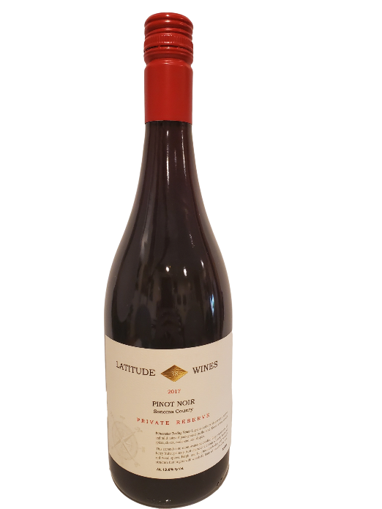
Varietal Compositions: Pinot Noir
Appellation: Sonoma County
Alc. 13.6% By Vol.
SRP: $34.99
TASTING NOTES:

A very expressive nose and smooth and silky on the palate. This medium-bodied wine is brimming with notes of bright red cherry, raspberry, and rhubarb. There's a sense of steeped green tea that adds some savory complexity. The finish is long, driven by persistent, yet balanced acidity.

