2017 PRIMROSE TRAIL, CABERNET SAUVIGNON,

2018 Trivia Big Red Blend Lodi

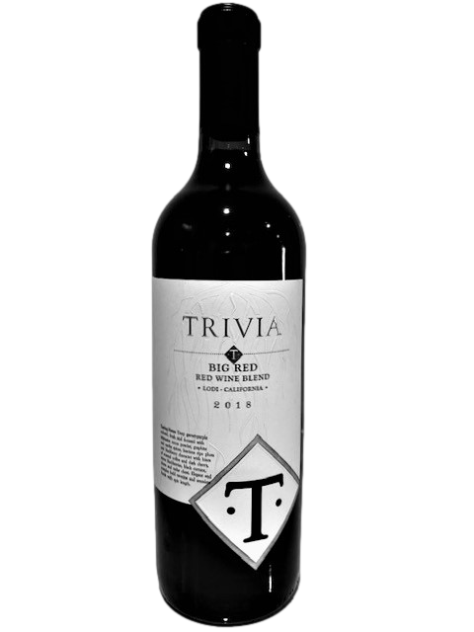
WINE SPECIFICATIONS:

Vintage: 2018
Varietal Compositions: Red Blend
Appellation: Lodi
Alc. 13.8% By Vol.
SRP: $19.99
TASTING NOTES:

Deep garnet-purple colored, fresh and focused with expressive cocoa powder, graphite and earthy spices, luscious ripe plum and blackberry character with hints of roasted coffee and dark cherry, warm blackberries, black currant, cloves, and cedar chest. Elegant and complex bold tannins and seamless finish with epic length.

