94 Pts.  2018 Trivia, Big Red Blend, Lodi  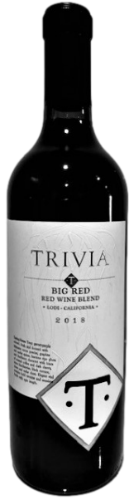  Review: The blend is smooth and decadent without being too heavy. there is a freshness to the raspberry and red plum tones, but plenty of ripe dark fruit to the wine as well. All of this is accented by a dustiness as well as a mocha tone. A big red that is very easy to drink.  SRP: $19.99 |  | 94 Pts.  2018 Trivia, Big Red Blend, Lodi  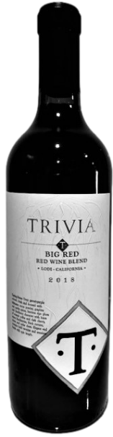  Review: The blend is smooth and decadent without being too heavy. there is a freshness to the raspberry and red plum tones, but plenty of ripe dark fruit to the wine as well. All of this is accented by a dustiness as well as a mocha tone. A big red that is very easy to drink.  SRP: $19.99
94 Pts.  2018 Trivia, Big Red Blend, Lodi  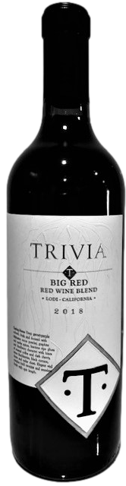  Review: The blend is smooth and decadent without being too heavy. there is a freshness to the raspberry and red plum tones, but plenty of ripe dark fruit to the wine as well. All of this is accented by a dustiness as well as a mocha tone. A big red that is very easy to drink.  SRP: $19.99 |  | 94 Pts.  2018 Trivia, Big Red Blend, Lodi  Review: The blend is smooth and decadent without being too heavy. there is a freshness to the raspberry and red plum tones, but plenty of ripe dark fruit to the wine as well. All of this is accented by a dustiness as well as a mocha tone. A big red that is very easy to drink.  SRP: $19.99  SRP: $75.00

